“A Time to Remember”
A Community Conversation on Alzheimer’s in Communities of Color

ALZHEIMER'S EDUCATION WORKSHOP
Saturday, October 14, 2023, 10:00 am – 12:30 pm

Hosted by
Cornerstone Community Baptist Church
4895 Campbellton Rd., SW, Atlanta, GA 30331
Dr. W. J. Lawson, Sr., Senior Pastor

In-person & Virtual (Streamed Live: Facebook Live and YouTube Channel)

AGENDA

SATURDAY, OCTOBER 14, 2023, 10:00 AM - 12:30 PM
WORKSHOP GOALS: Alzheimer’s disease (AD) is the most common form of dementia. More than 4 million Americans have AD. The disease is characterized by memory loss, language deterioration, poor judgment, and an indifferent attitude. Dementia is a brain disorder that seriously affects a person’s ability to carry out daily activities. It involves the parts of the brain that control thought, memory, and language. Healthy brain tissue dies or deteriorates, causing a steady decline in memory and mental abilities. The goals of this education program are to help attendees: 1) Understand Alzheimer’s and Dementia and recognize the signs and symptoms to promote early diagnosis, 2) Build a therapeutic alliance between physician and caregiver as an essential element in successfully managing their loved one’s AD, 3) Learn, understand, and apply techniques to reduce behavioral disturbances in a compassionate way, promote independence, activity and socialization to limit the need for pharmacologic management, and 4) Learn about available caregiver trainings and social support resources.

MODERATOR: Stan Watson, National Director of Faith Initiatives & Policy, HEAL Collaborative

10:00 AM WELCOME, PRAYER, AND OPENING REMARKS
Dr. W. J. Lawson, Jr., Senior Pastor, Cornerstone Community Baptist Church

10:05 AM KEYNOTE SPEAKER
“What is Alzheimer’s? Why does Alzheimer's affect African Americans differently than other races? Risk factors and symptoms for developing Alzheimer’s.

Deborah Rose, MD, 4th Year Resident, Neurologist, Duke University, School of Medicine

Q&A SESSION: AUDIENCE PARTICIPATION

10:45 AM CAREGIVER JOURNEY PANEL
Caregivers share their stories of courage and challenges during their loved one’s stages and journey with Alzheimer’s and Dementia—from screening and diagnosis to seeking support and resources.

SPEAKERS
    - Malcoma Brown-Ekeogu, Caregiver Advocate (FTD) and Entrepreneur
    - Sharon Jackson, Caregiver/Support Group Volunteer, Dementia Spotlight Foundation

Q&A SESSION: AUDIENCE PARTICIPATION

11:10 AM PATIENT NAVIGATION, CARE, AND RESOURCE PANEL
What early detection and screening look like for patients. Navigating patients through treatment, assisting in organizing their care, and providing education and assistance each step of the way to survivorship.

SPEAKERS
- Debra Stokes, Executive Director, Georgia Council on Aging
- Xavier Crockett, District Program Director, Clayton County Health District, Georgia Department of Public Health

Q&A SESSION: AUDIENCE PARTICIPATION

11:50 AM POLICY CONVERSATION

SPEAKERS
      - Representative Roger Bruce, Democratic Member of the Georgia House of Representatives, District 61
- Howard Mosby, Corporate Treasurer/Board Member, HEAL Collaborative and Former Member of the Georgia House of Representatives, District 83

Q&A SESSION: AUDIENCE PARTICIPATION

12:20 PM CALL-TO-ACTION

12:30 PM FINAL REMARKS, LUNCH ANNOUNCEMENT & CLOSING PRAYER
Dr. W. J. Lawson, Jr., Senior Pastor, Cornerstone Community Baptist Church

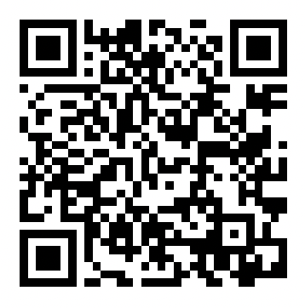

Alzheimer’s & Dementia Resources

